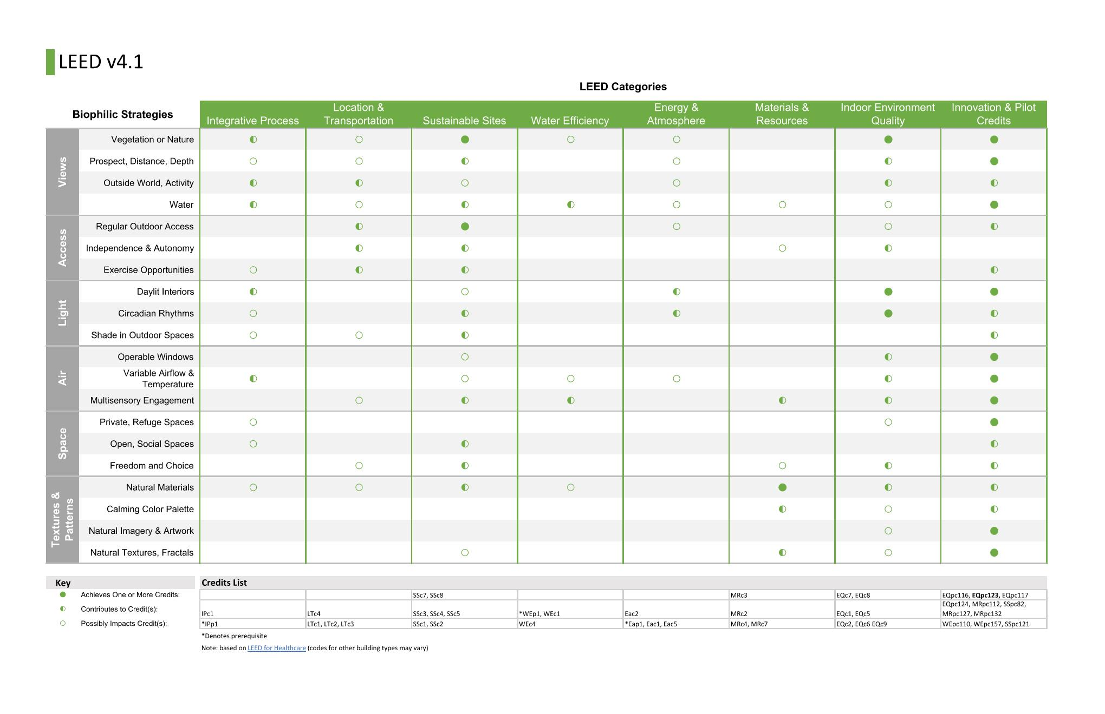
Jack Reed 2020-2021: Biophilia in Behavioral Health
Although the benefits of biophilia are numerous, behavioral health projects also present a variety of challenges and considerations related to observation, security, maintenance, and safety. This project will explore those design considerations and identify actionable strategies outlining how biophilic design can balance these factors to improve patient and staff outcomes, while enhancing a project’s financial and environmental performance.Design recommendations will primarily address qualitative aspects of patient care, but will also reference existing frameworks such as LEED and WELL, which have begun to adopt principles of biophilic design.

